10PEARLS SHINE
Data Science Internship Program
AQI FORECASTING SYSTEM
Multi-Horizon Air Quality Index Prediction
for Faisalabad, Punjab — 24h / 48h / 72h Forecasts
Prepared by
Muhammad Ibrahim

1. Aim & Objective
This project implements a fully serverless, end-to-end machine learning system that forecasts the Air Quality Index (AQI) for Faisalabad, Punjab across three horizons — 24h, 48h, and 72h ahead. Built as part of the 10Pearls Shine Data Science Internship Program, it covers the complete applied ML lifecycle: automated hourly data ingestion, feature engineering, model training and evaluation, SHAP-based explainability, and a live-serving dashboard.

Objectives
- Automate hourly ingestion of live weather and pollutant data with zero manual intervention.
- Engineer a horizon-aware feature set (lags, rolling statistics, cyclical time encodings) for short- and long-range forecasting.
- Independently benchmark and select the best model per forecast horizon, validated against a naive persistence baseline.
- Apply SHAP explainability with physical atmospheric domain checks (wind dispersal, rain washout, pollutant momentum) as an interpretability sanity layer.
- Automate daily model retraining so the system continuously incorporates new data.
- Deploy a production dashboard surfacing forecasts, hazard alerts, and explainability in real time.

2. System Architecture & Pipeline
The system runs as four automated stages — data collection, feature engineering & storage, model training & evaluation, and deployment — with no manual steps after initial setup.
Stage | Technology | What it does
Data Collection | Open-Meteo API + GitHub Actions (hourly cron) | Fetches live weather + pollutant data every hour; appends to the feature store with automatic timestamp deduplication.
Feature Engineering | Python / pandas | Cyclical time encodings (hour/day/month sin-cos), multi-horizon AQI & PM2.5 lags (1h–72h), rolling means/sums, AQI change-rate — ~51–55 features per horizon.
Feature Store | Supabase (Postgres) | Append-only aqi_features table; single source of truth for both training and live inference.
Model Training | scikit-learn, CatBoost + GitHub Actions (daily cron) | Chronological split, 72h embargo buffer, persistence-baseline gate. Retrains once daily, decoupled from hourly data fetch.
Explainability | SHAP (Kernel / Tree Explainer) | Horizon-specific, multi-fold-stable feature pruning, validated against physical atmospheric rules.
Deployment | React (Vite + Tailwind) + Flask API | Serves live forecasts, SHAP explanations and hazard alerts to the dashboard via REST API.

Seven model families — Ridge, Random Forest, SVR, XGBoost, LightGBM, CatBoost, and a PyTorch LSTM — were benchmarked per horizon against the persistence baseline; all seven beat it, and the strongest performer per horizon was carried into SHAP-driven feature refinement (horizon-specific pruning, 3-fold TimeSeriesSplit stability checks, and sequential feature-expansion testing).

Horizon-Specific Training Strategy
A controlled ablation (1.5 vs. 3 years of training data, identical frozen test window) showed each horizon benefits from a different strategy:
Horizon | Sample Weighting | Rationale
Day 1 (24h) | Exponential recency decay | Short-horizon forecasts depend most on very recent atmospheric momentum.
Day 2 (48h) | Unweighted (full 3-yr data) | Achieved the lowest RMSE; a smog-penalty-weighted variant is retained as a hazard-prioritized alternative.
Day 3 (72h) | Unweighted (full 3-yr data) | Long-horizon forecasts benefit most from broad seasonal coverage rather than recency.

Final Production Results
Evaluated on an identical, frozen 5,212-hour chronological test window (14 Jan 2026 20:00 – 19 Aug 2026 23:00):
Horizon | Model | Preprocessor | RMSE | MAE | R² | Persist. RMSE | Edge
Day 1 (24h) | SVR | StandardScaler | 22.81 | 17.49 | 0.7224 | 28.25 | −19.2%
Day 2 (48h) | SVR | RobustScaler | 29.91 | 22.77 | 0.4860 | 35.00 | −14.5%
Day 3 (72h) | CatBoost | None | 31.67 | 24.22 | 0.3899 | 38.14 | −17.0%

Horizon | Top SHAP Feature | Physical Interpretation
Day 1 | pm2_5_change_rate_1h | Rapid 1h PM2.5 shifts drive next-day trajectory.
Day 2 | us_aqi_lag_24h / lag_48h | Autoregressive day-over-day momentum.
Day 3 | us_aqi_lag_72h | 72h autoregressive lag — strongest long-range anchor.
Day 3 | month_sin / month_cos | Seasonal regime: winter smog vs. summer.

All three models beat persistence with a meaningful margin; artifacts (best_aqi_day{1,2,3}.joblib + scalers) were verified by loading each object and confirming its Python type/hyperparameters, not just file presence.

Deployment & Dashboard
A React (Vite + Tailwind) single-page dashboard renders live AQI, the 3-day forecast breakdown, hourly strip, hazard alerts, and SHAP explainability panels, backed by a Flask API that loads model + scaler artifacts and queries Supabase for the latest feature row.
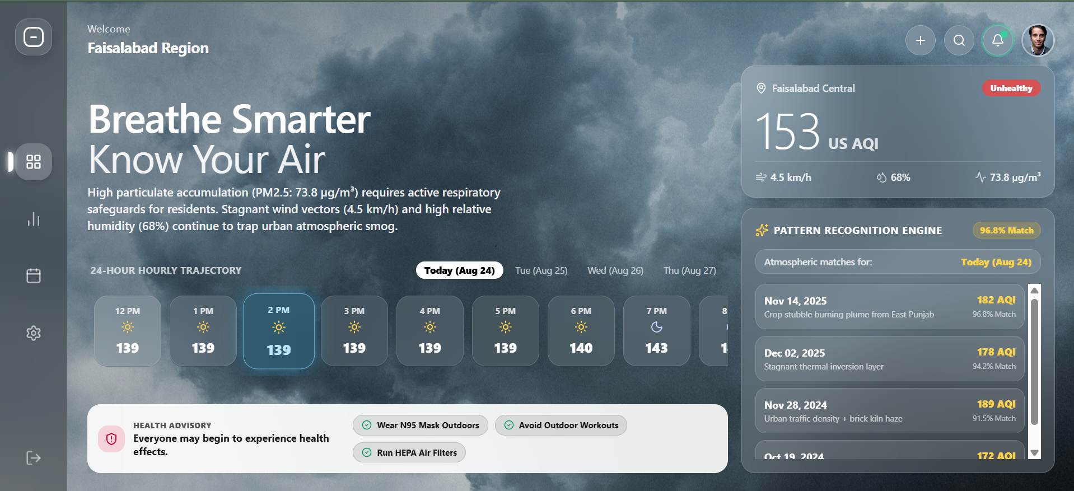

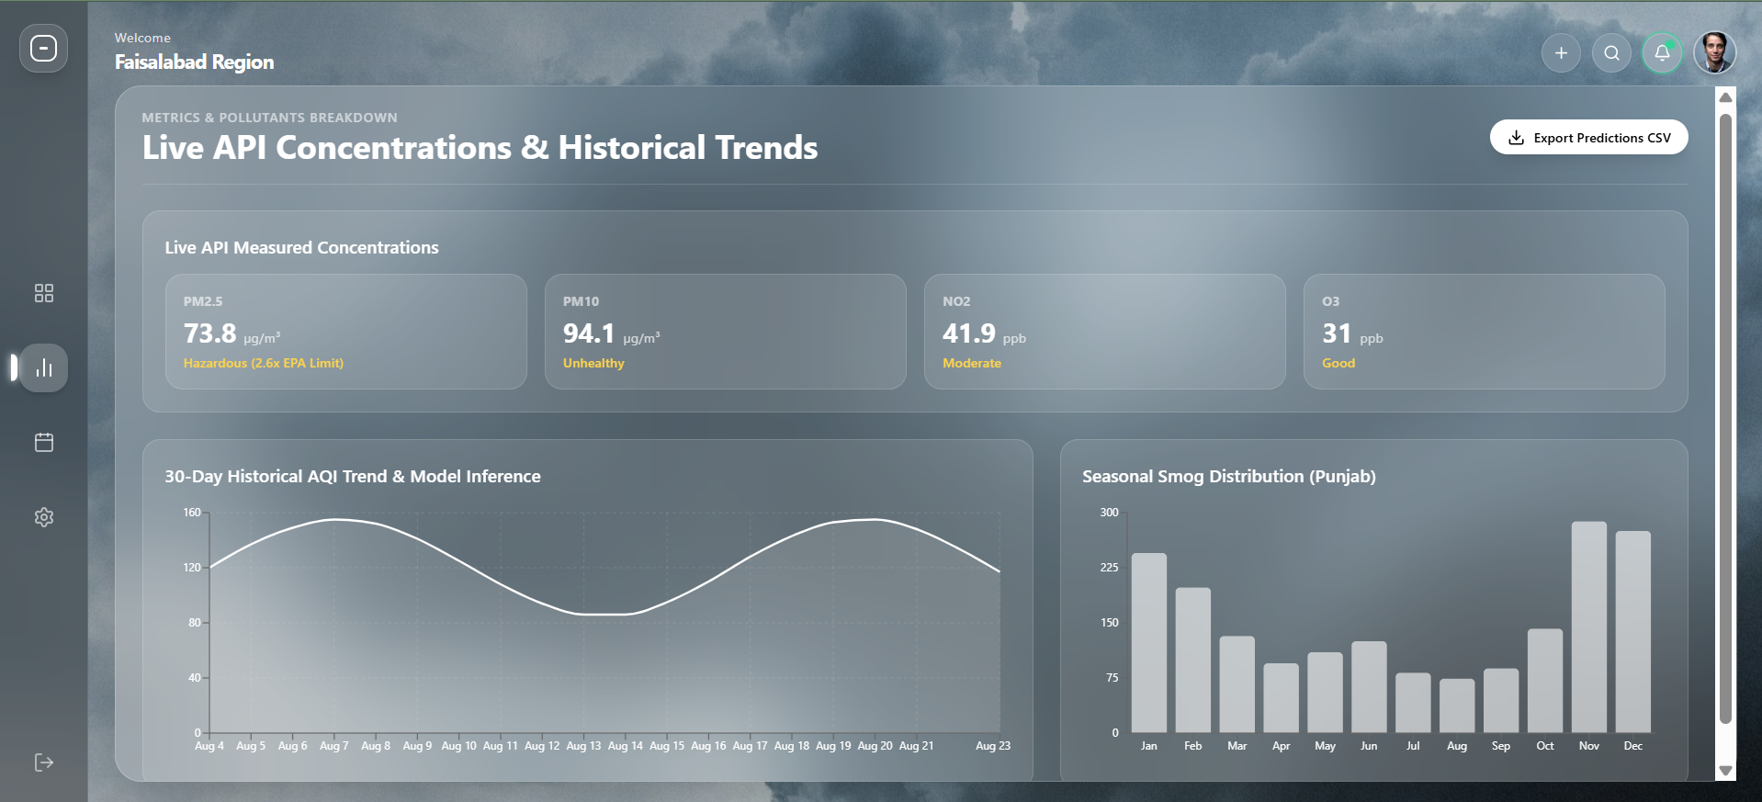

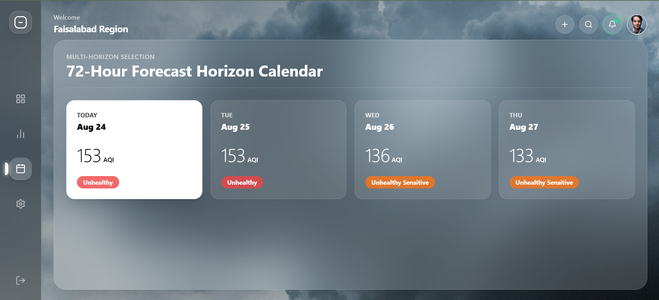

3. Challenges Faced & Engineering Solutions
Nine distinct technical challenges were identified and resolved during model development. In every case, the guiding principle was the same: never accept a surprising or convenient result at face value — trace it back to its root cause with direct, verifiable evidence before it enters the production pipeline.

3.1 SHAP / SVR Scaling Bug
Problem: During SHAP analysis on the Day 1 model, all 51 features returned near-zero SHAP importance, and physical domain checks returned +nan correlations.
Resolution: Root-caused to a scaling mismatch: SVR was trained on scaled data via StandardScaler, but the SHAP KernelExplainer was fed raw, unscaled test data — pushing all values outside SVR's expected range and collapsing predictions (and SHAP values) to a near-constant, producing 0/0 = NaN correlations.
Result: Passing the properly scaled test set into the explainer restored accurate SHAP importances and valid correlations (e.g., −0.85 for wind dispersal). This also triggered an audit ensuring the same fitted scaler is persisted and reused at inference time.

3.2 Confounded Data-Volume Comparison (1.5-Yr vs. 3-Yr)
Problem: An initial 1.5-year vs. 3-year data comparison showed mixed results, but was invalid — both training volume and test window were changed simultaneously, making the true cause unidentifiable.
Resolution: Ran a controlled ablation: froze a single 5,199-hour test window and evaluated both models on the exact same data, isolating data volume as the sole variable.
Result: Day 1 performed marginally better with 1.5-year data (+0.48 RMSE for 3-yr); Day 2 and Day 3 improved meaningfully with 3-year data (−1.21 / −1.12 RMSE), directly motivating a per-horizon training strategy.

3.3 Per-Horizon Weighting Strategy
Problem: The ablation above proved a single unified training approach was suboptimal across horizons.
Resolution: Rather than fragmenting the pipeline with different dataset truncations, a unified 3-year dataset was retained with horizon-specific sample weighting instead — exponential recency decay (Day 1), smog-penalty weighting benchmarked vs. unweighted (Day 2), and no weighting (Day 3).
Result: Each decision was validated with explicit before/after RMSE comparisons, turning intuition (“recent data matters more short-term”) into a numerically justified design choice.

3.4 Day 2 Model Selection Inconsistency
Problem: The Day 2 “production winner” flipped between CatBoost and SVR across iterations, sometimes on RMSE differences as small as 0.1–0.3 points, with no consistent selection rule.
Resolution: Standardized the rule: lowest raw RMSE is the default winner unless a deliberate, written override is made.
Result: Selected SVR + RobustScaler (unweighted), 29.91 RMSE as the Day 2 winner; the smog-weighted variant (30.16 RMSE) was retained as a documented, hazard-prioritized alternative.

3.5 R² Anomaly (Jump from ~0.36 to ~0.72)
Problem: After expanding to 3-year data, Day 1's R² nearly doubled while RMSE barely changed — mathematically suspicious, since R² and RMSE are directly linked via target variance.
Resolution: Verified R² against the identity R² = 1 − RMSE²/Var(y_test), then audited the raw test target array itself (mean, min/max, variance, date range) rather than trusting the algebra alone.
Result: The raw test set genuinely spanned 68.73 to 371.34 AQI across a full seasonal cycle, producing genuinely high variance (Var = 1874.11) — confirming a real, explainable result, not a leakage bug.

3.6 SVR vs. CatBoost “Tie” (Day 2 & Day 3)
Problem: SVR and CatBoost repeatedly traded the “winner” spot with margins as small as 0.1–0.5 RMSE — too small to represent a genuine difference.
Resolution: Ran 5-fold TimeSeriesSplit cross-validation for both models, comparing mean RMSE ± standard deviation instead of a single split.
Result: Day 2: SVR 34.85±6.72 vs. CatBoost 34.37±6.92; Day 3: SVR 36.09±6.79 vs. CatBoost 35.86±7.29. Both within one standard deviation — documented explicitly as a statistical tie.

3.7 Outlier Legitimacy Verification
Problem: The test set's max raw AQI (371.34) was extreme enough to warrant scrutiny — genuine event, or sensor glitch?
Resolution: Inspected hour-by-hour readings around the peak timestamp rather than assuming either way.
Result: A smooth, continuous multi-hour ramp (358.47 → 371.34 (peak) → 368.38, all Δ < 5/hr) confirmed a genuine, sustained smog crisis, not a sensor error.

3.8 Test Window Consistency Across Horizons
Problem: With separate iterative experiments per horizon, final metrics risked being computed on mismatched test windows, invalidating cross-horizon comparison.
Resolution: Explicitly verified and logged the shared test date range and row count across all three models.
Result: Confirmed all three were evaluated on the identical 5,212-hour window (14 Jan–19 Aug 2026), removing any mismatch risk.

3.9 Artifact / Configuration Match Verification
Problem: Given how often the “winning” configuration changed (especially Day 2), saved .joblib files risked being stale leftovers from an earlier iteration.
Resolution: Went beyond confirming files existed — loaded each artifact directly and inspected its actual Python type and hyperparameters against the reported winner.
Result: All three pairs matched exactly: Day 1 (SVR+StandardScaler), Day 2 (SVR+RobustScaler), Day 3 (CatBoost, no scaler) — all verified PASS.

4. Conclusion & Future Work
This project delivered a fully automated, serverless AQI forecasting system for Faisalabad, covering hourly ingestion through daily retraining to a live, explainable dashboard. All three production models beat the naive persistence baseline with statistically validated, artifact-verified confidence, and every design decision is backed by documented, reproducible evidence.

Future Work
- Extend alerting with SMS/email notifications for hazardous AQI, prioritizing Day 2 given its weaker winter-smog performance.
- Expand multi-city coverage using the same feature pipeline architecture.
- Revisit deep learning (LSTM/Transformer) now that a 3-year training corpus is available.
- Add automated model-drift monitoring to the daily retraining workflow.

5. Exploratory Data Analysis (Appendix)
A 10-point EDA was performed on the full 3-year Supabase dataset (26,160 hourly rows, 26 Aug 2023 – 19 Aug 2026, 56 columns) to validate data integrity and surface the trends that motivated the feature engineering and modeling decisions above.
# | Trend | Key Finding
1 | Missing Data & Timestamp Gaps | Zero missing values across all features; zero timestamp gaps (>1h) — dataset timeline fully continuous.
2 | Diurnal (24h) Pattern | Peak AQI at 13:00 (mean 172.7); lowest at 4:00 (mean 158.8).
3 | Day-of-Week Pattern | Friday highest (mean 164.3); Tuesday lowest (mean 158.3) — a modest, not dramatic, weekday effect.
4 | Monthly / Seasonal Pattern | Winter smog season (Nov–Feb) averages 210.4 AQI vs. 137.3 the rest of the year (+53%).
5 | Year-over-Year Trend | Mean AQI relatively stable across years: 2023=163.9, 2024=158.6, 2025=163.1, 2026(partial)=162.2.
6 | AQI Category Breakdown | Good 0.0% · Moderate 10.6% · Unhealthy-Sensitive 30.1% · Unhealthy 42.9% · Very Unhealthy 13.5% · Hazardous 3.0%.
7 | Wind Speed vs. AQI | Pearson r = −0.31 — confirms the wind-dispersal rule (higher wind, lower AQI).
8 | Precipitation (Rain Washout) | Dry hours average 163.2 AQI vs. 130.4 on rainy hours — a 20% reduction, confirming rain washout.
9 | Feature Correlation | Strongest AQI correlates: PM2.5 (r=0.76), PM10 (r=0.62), surface pressure (r=0.49), temperature (r=−0.49).
10 | Autocorrelation (ACF/PACF) | Lag-1h autocorrelation ~0.95+; periodic ACF peaks every 24h (24/48/72/96h) justify the multi-day lag features used.

Selected Charts
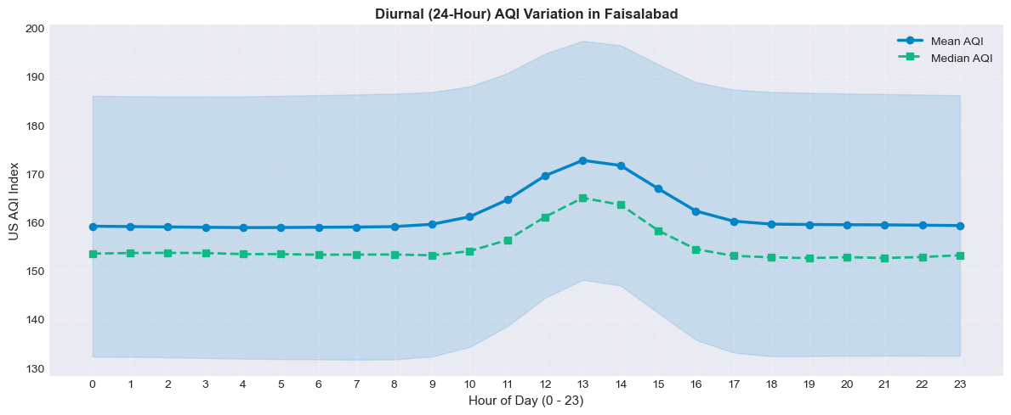  Diurnal AQI pattern — 24h mean/median. | 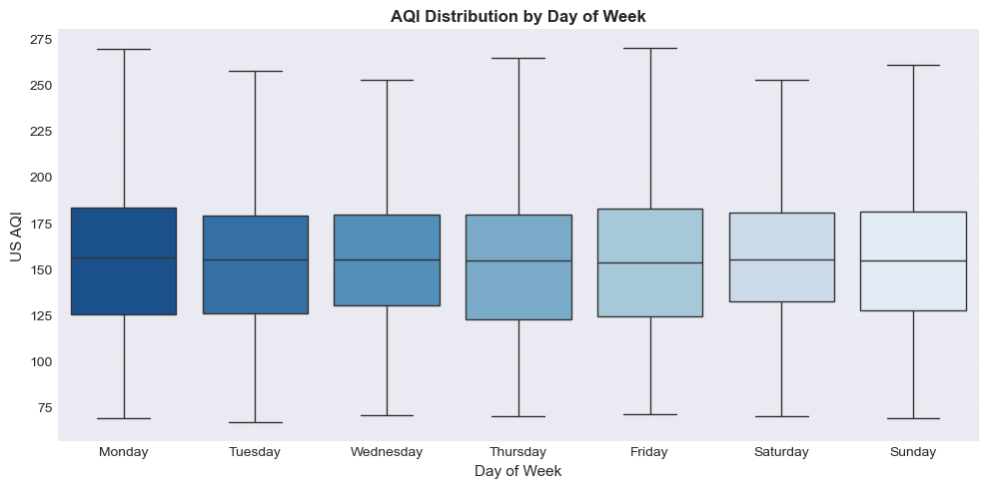  AQI distribution by day of week.
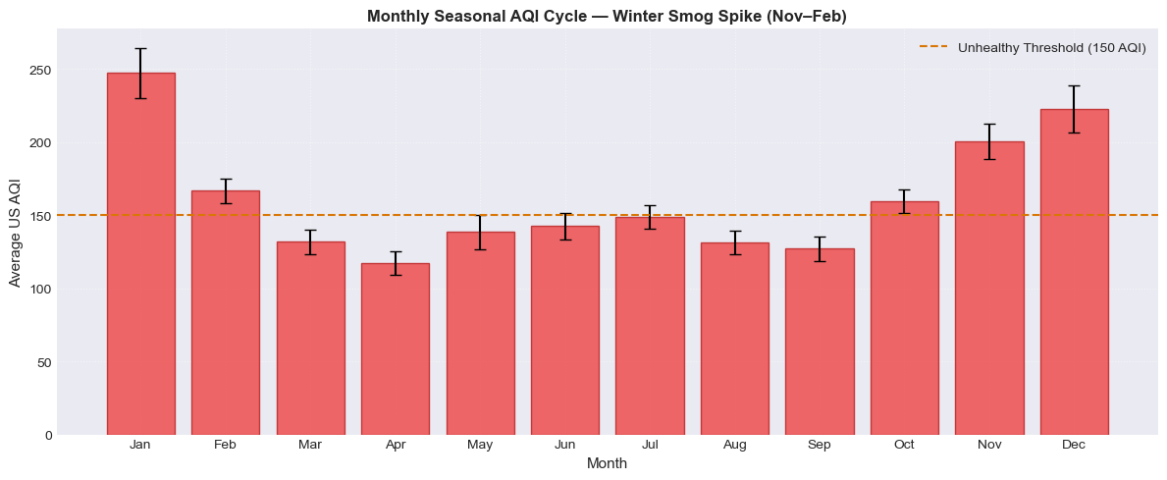  Monthly average AQI — winter smog vs. normal months. | 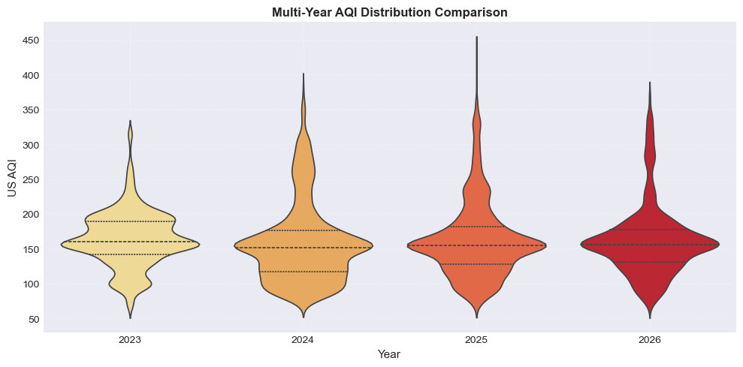  Year-over-year AQI distribution (violin plot).
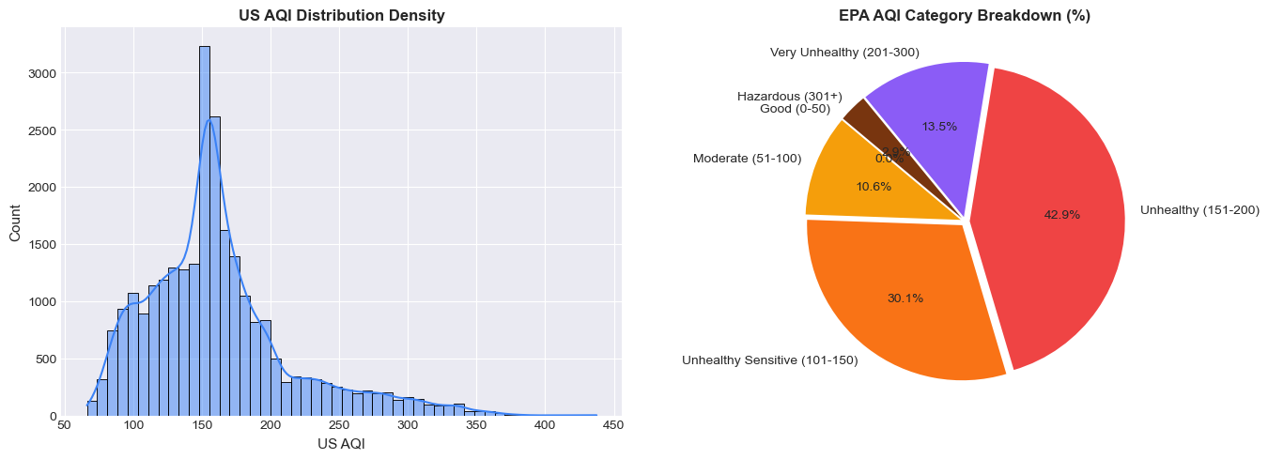
AQI distribution density and EPA category breakdown.
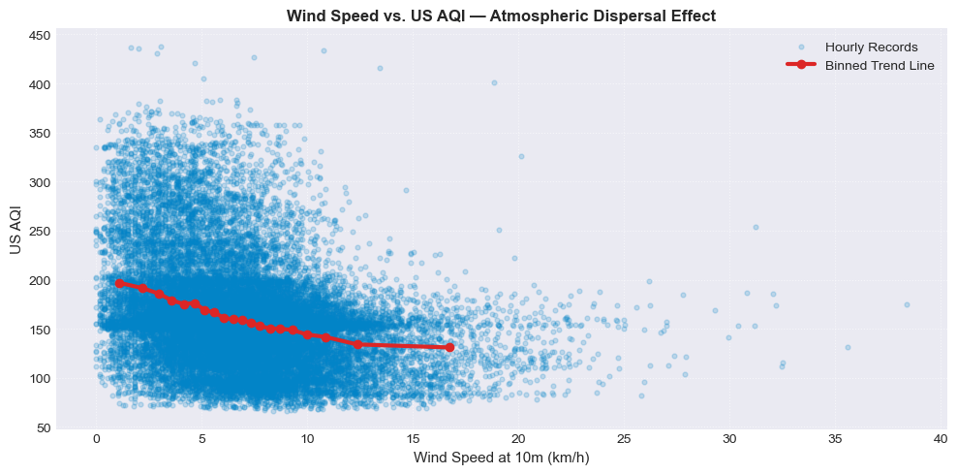  Wind speed vs. AQI (dispersal effect). | 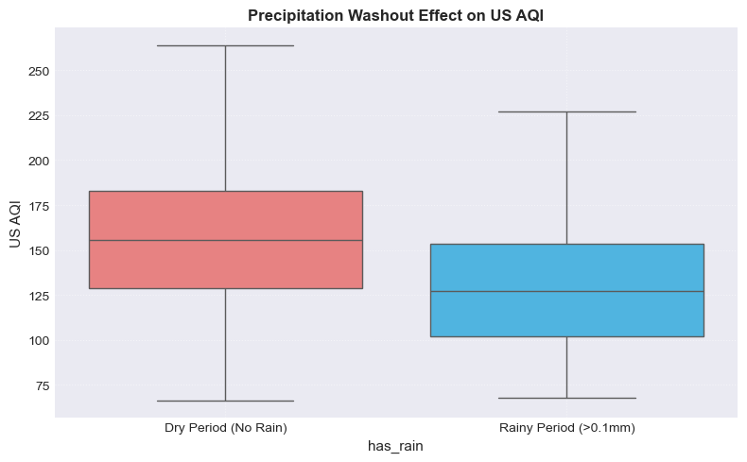  AQI on rainy vs. dry hours (washout effect).

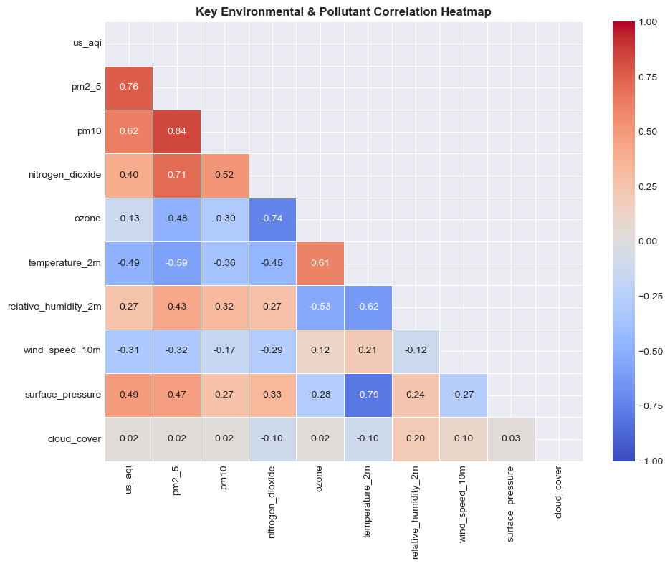
Correlation heatmap — weather & pollutants vs. AQI.
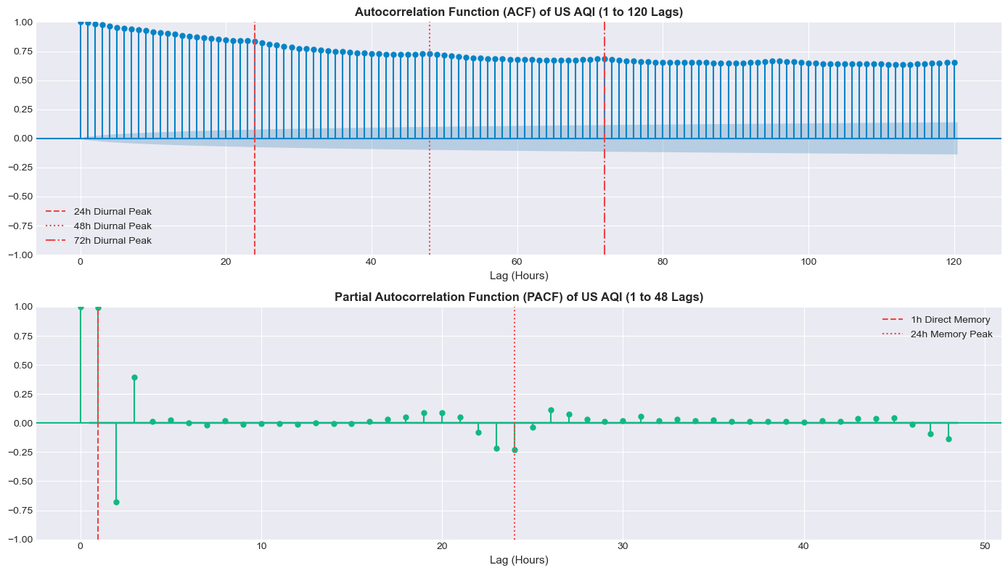
ACF (top) and PACF (bottom) of AQI, up to 120 / 48 lags.

